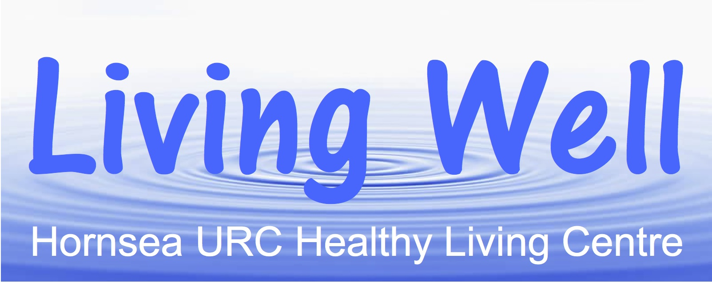

**Living Well Project – Volunteers Newsletter – September 2019**

**Hi Everyone**

**Hope you are all still enjoying the sunny weather. Many thanks to everyone for keeping the phone lines open throughout the summer holidays and supporting the new Healthy Lifestyle Programme.**

**It is confirmed that there will be a Dementia Workshop on Monday 16th September in the Church Hall starting at 1.30pm. Please get in touch with Sarah or David if you would like to come along or if you know of any friends or family members that would like to join us. It is open to everyone.**

**A new promotional video about the project’s work has recently been produced with the help of the SMILE Foundation which was filmed during a Living Well lunch on 24th April. This video will soon be posted on the Living Well website.**

**The weekly Healthy Lifestyle Programmes continue to run up to Christmas. Please continue to encourage TSN clients to come along on a Friday morning; a number of whom find their own way there. Individuals may approach HART community transport if they are unable to get there by public transport.**

**The East Riding Council Social Prescribing Team have launched a website to help individuals promote their own health and wellbeing. The site contains a range of information which may also be useful to Living Well volunteers. To find out more connect on** [**www.happyandwell.me**](http://www.happyandwell.me)

**A note for your diary is Friday 4th October when the annual reporting meeting and celebration will be held in the Church at 12.30pm. The meeting gives us the opportunity to update local Councillors and our partners who are supporting and promoting the project. As there is a buffet lunch if you are able to attend can you please advise Sarah by 15th September at the very latest.**

**In the meantime, once again, many thanks for all your hard work for the project which really does make a difference.**