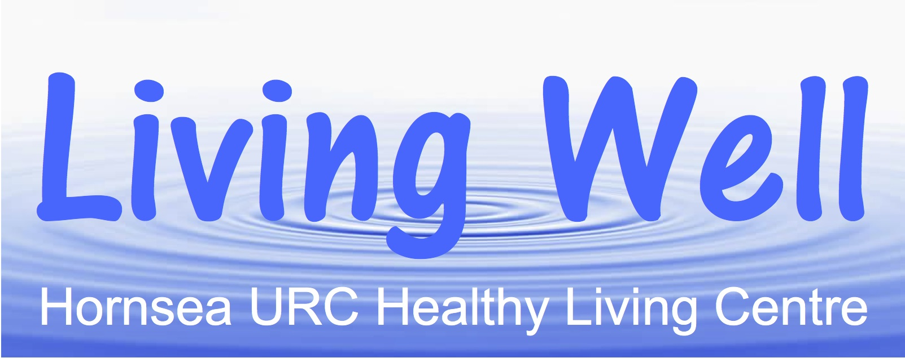

**Living Well Project – Volunteers Newsletter – August 2019**

**Hi Everyone**

**Hopefully everyone is managing to keep cool and cope with the heatwave. In the meantime let’s remember to use less plastic and walk everywhere to save the planet! Many thanks to all the TSN volunteers for working hard despite the heat to keep the rotas full and enabling the September list to be on the notice board in such good time.**

**The project has just received the first installment of a £3,000.00 Building Community Health Grant from the ERYC Social Prescribing Team. This will enable us to run a six month structured Healthy Lifestyle programme and purchase a new computer. The Healthy Lifestyle will continue on Friday mornings in the church hall and details are available at the TSN sessions, on the notice boards and published in the Hornsea Community News.**

**In this new series the exercise sessions will be themed around Mobility, Strength and Balance, as well as Gentle Exercise for relaxation. There will be some new sessions on aspects of Healthy Eating and the Pharmacist from Eastgate Surgery will lead a discussion on Managing our own Medication. The popular Tech Surgeries led by Sal Cooke will continue on the last Friday of each month.**

**The new programme is also providing more opportunities for volunteering. Greg Harman has led a very encouraging session on Valuing Ourselves and Our Own Skills. Margaret has demonstrated the benefits of Resistance Bands for exercise, Jan has shown us how to relax through Indoor Gardening and Tamar is leading a session in September on Creativity for Wellbeing. Spencer, a fifteen year old lad undertaking the Duke of Edinburgh’s Silver Award, is helping at Tech Surgeries and Pauline assisted a visually impaired participant with her device last month. Many thanks to Steve who has joined the team of Volunteer Drivers for the monthly lunches.**

**Have a good summer and relax when you can!**