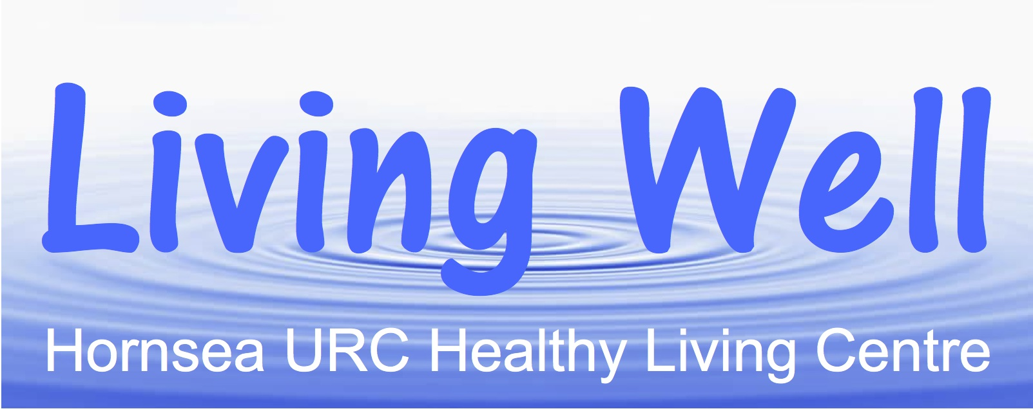

**“TECH SURGERY” with Sal COOKE**

**10am-12noon in HURC CHURCH HALL**

**NEW ROAD, Hornsea, HU18 1PG**

**ADVICE AND HELP WITH ANY TECH ISSUE TO INCLUDE**

**I PADS, LAP TOPS, SMART PHONES,ANDROIDS, KINDLES, ETC**

**Bring Your Own Device or Just Drop In For Advice**

**Friday 26th JULY**

**Friday 30th AUGUST**

**Friday 27th SEPTEMBER**

**Friday 25th OCTOBER**

**Friday 29th NOVEMBER**

**Further Information phone David 07956 924335 or 01964 534553**