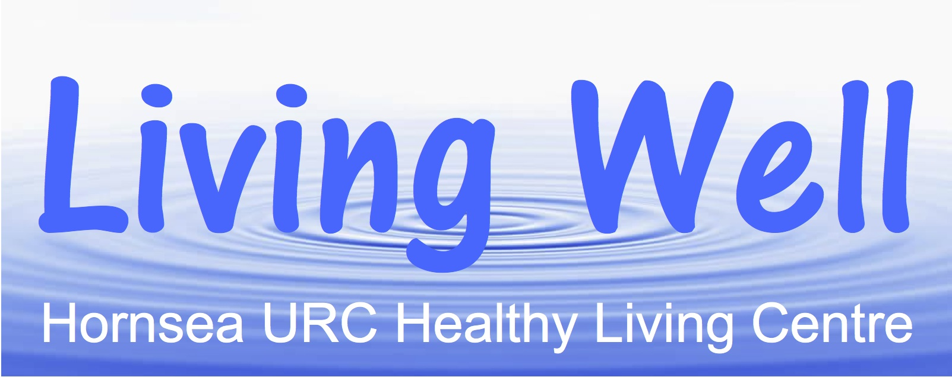

**HEALTHY LIFESTYLE SESSIONS JULY-SEPTEMBER 2019**

**All Sessions take place on Friday Morning between 10am and 12noon in HURC Hall, New Road, Hornsea, HU18 1PG**

**Friday 12th July - Indoor Windbox Gardening**

**With Jan Rogers**

**Friday 19th July - Valuing Ourselves and Our Skills**

**With Greg Harman of Second Thoughts**

**Friday 26th July - Tech Surgery with Sal Cooke**

**Friday 2nd August - Mobility with Mandy Hood/Lindsey Illingworth**

**Friday 9th August - No Session – Premises not Available**

**Friday 16th August - Managing your Own Health**

**With Emma Andrews, Link Worker,**

**Eastgate Surgery.**

**Friday 23rd August - Relaxation and Creative Breathing**

**With Helen Gray of Yes To Yoga**

**Friday 30th August - Tech Surgery with Sal Cooke**

**Friday 6th September - No Session**

**Friday 13th September - Strength and Balance with Mandy Hood/**

**Lindsey Illingworth**

**Friday 20th September - Creativity for Wellbeing with Tamar Simpson**

**Friday 27th September - Tech Surgery with Sal Cooke**

**For further details contact David Radford 01964 534553/07956 924335**

**Sarah Darlington at sarah.darlington538@gmail.com**