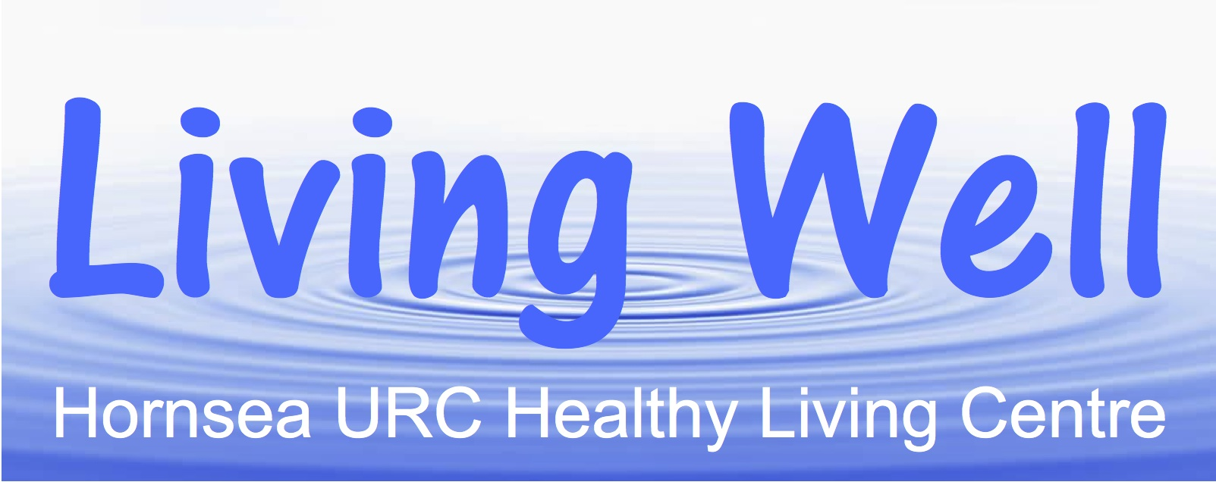

**Living Well Project – Volunteers Newsletter – July 2019**

**Hi Everyone**

**As we enter the second half of the year, looking forward to a warm and sunny summer, once again we would like to thank everyone for your hard work and commitment to the project. Your contribution really does make a difference and we hope to ensure that everyone receives their National Volunteers Week Certificate by the end of the month.**

**“Tech Surgeries” with Sal Cooked are now planned for the last Friday morning of each month up to and including November. The next two sessions will take place on 26th July and 30th August. Several new participants have attended each sessions and are really getting to grips with their tech devices. Please encourage anyone you think could benefit to come along. Fliers are available and the programme is advertised regularly in the Hornsea Community News.**

**Following the discussion at the Volunteers Meeting on 5th June, a Dementia Awareness Workshop with Richard Neale will be held on Monday 19th August at 2pm in the HURC Hall. It lasts for about an hour and a half and refreshments will be available. Several people have already signed up but if you would like to attend please let Sarah know.**

**The East Riding Council has approved the project’s application for a Building Community Health grant to fund the next phase of our Healthy Lifestyle progamme on Friday mornings. We are now consulting widely with local groups and organisations to plan a detailed programme throughout the autumn and winter. If you have any thoughts or ideas about what to include or indeed if you feel you could make a contribution please let David or Sarah know. Some volunteers have already offered to lead sessions on Friday mornings over the summer.**

**Once again, many thanks and best wishes to everyone.**